1. Date: Sunday, May 15, 2022 Start time: 3:00pm 1211 Porter Street, Richmond, VA 23224
(Mailing Address Above)

2. ASC Chairperson:
Open RASCNA with the Serenity Prayer
Chair Read: Purpose
12 Traditions: Sheila G.
12 Concepts: Anthony F.
Chair Read: Purpose, Privilege and Home Group Information

a. It is a privilege for NA to use this facility. We must ask that all children remain under adult supervision at all times. The space that has been rented to us consists of the meeting room, NA Literature Room and the rest rooms.
b. Any home groups here today that have information to present about their home group that can affect our primary purpose? For example, changing of meeting time and/or location; meeting changing due to holidays; any problems with addicts’ behavior that could jeopardize a meeting space; meeting closing for any reason; or home group functions.

Home Groups/Area Concerns:

Notes:
All motions to change the order of the day must be turned in prior to the start of the business to be considered. Motions to change the order of the day turned in after the start of business must be approved by the Chairperson in order to be considered. All changes to the order of the day must be heard and receive a majority vote of the GSRs before the change to the order of the day can happen.

Motion to change the order of the day. To allow the treasurer to give her report and handle Money Matters first due to medical issues, and she will be available for questions VIA phone/facetime.
Intent: To allow and ensure all financial business to be addressed during this meeting of area service.
Motion Maker: Policy Seconded By: Not Needed
Votes: YES: 10 NO:0 ABSTAIN:1 Passed

Motion to change the order of the day: To bring back discussion on RASCNA maintaining a zoom account.
Intent: Tradition 5. Our primary purpose is to carry the message to the addict who still suffers. Tradition 2. Our leaders are but trusted servants.
Motion Maker: Richard W. Seconded By: Neal E.
Votes: YES: 9 NO:0 ABSTAIN:1 Passed

Timekeeper: Hardy E.

3. Attendance Roll Call by Secretary: Open: 24 / Closed: 13 / Voting: 13 / Reporting: 2 / Absent: 9 / Meetings: 0

TOTAL: 22 Groups 0 Meeting(s)

Richmond Area Groups
Open | Closed | Voting | Reporting | Absent | Meetings
1.Atmosphere Of Recovery  2. Church Hill Group  3.Clean Connection  4. Clean and Serene  5.Easy Pace/Stepping Out  6. Freedom Group  7.Good Orderly Direction  8.Growing In Recovery  9.Keeping It Simple In The AM  10. Long Haul Group  11.Monday Reality  12.More Will Be Revealed  13.New Beginnings  14.New Birth  15.Open Minds  16. Positive Thinking  17. Rainbows End  18.Shot of Hope  19. Simple Basics  20.Staying clean  21.Staying Clean Together  22.Stepping on Sundays  23.Sunday Spiritual  24.White Flag | - Blackwell Recovery  - East End Men’s Rap  - Friday Freedom [meeting]  - For The Newcomer  - Friday Feelings/ Sunday Basic Text  - In Times Of Illness  - Miracles in Recovery  - NA Sisters In Stride  - Not In The Fan  - Southside Recovery  - The Promise  - We Do Recover | - Atmosphere Of Recovery  - Church Hill Group  - Easy Pace/Stepping Out  - Good Orderly Direction  - Growing In Recovery  - Long Haul  - Monday Reality  - More Will Be Revealed  - New Beginnings  - New Birth  - Staying Clean  - Stepping On Sundays  - Sunday Spiritual | - Freedom Group  - Rainbows End | 1.Clean Connection  2.Clean and Serene  3.Keeping it Simple In the AM  4.Open Minds  5.Positive Thinking  6.Shot Of Hope  7.Simple Basics  8.Staying Clean Together  9.White Flag

4. Old Minutes reviewed and accepted: May 15, 2022 Minutes: Vote: 13/0/0 Passed

5. Executive Body Reports: May 15, 2022
ASC Chair | All is well, thank you all for allowing me to serve and I appreciate your patience as I continue to grow more familiar with the position as chair. I look forward to a great day with you all. I also want to say a special thank you to Kim M for her willingness to step into service as our Vice Chair of area.  In Loving Service, Stephanie T.
Announcements: | Stephanie T., (804) 677-4395. Email: rascnaasc@metrorichna.org
ASC Vice-Chair | No Report
Announcements: | Email: rascnaasv@metrorichmond.org
Secretary | Good Afternoon, Everyone  I want to start by apologizing for the delay on the minutes this month trying to make sure they were done correctly. The area gave me $50.00 to pay for the stamps to mail out the minutes. The purchase of stamps came to $30.16 and with the $19.84 that was left I purchased an $18.00 money order. All receipts given to the chair in lieu of the absence of our treasurer.  In Loving Service Lindsay A.
 | Lindsay A., (804) 688-0463. Email: rascnasec@metrorichna.org or RichmondAreaServiceCommitteeNA@gmail.com
Treasurer Report  (Lindsay, plug in the info when it comes to the Treasurer’s Report whereas there’s a table in this cell) | 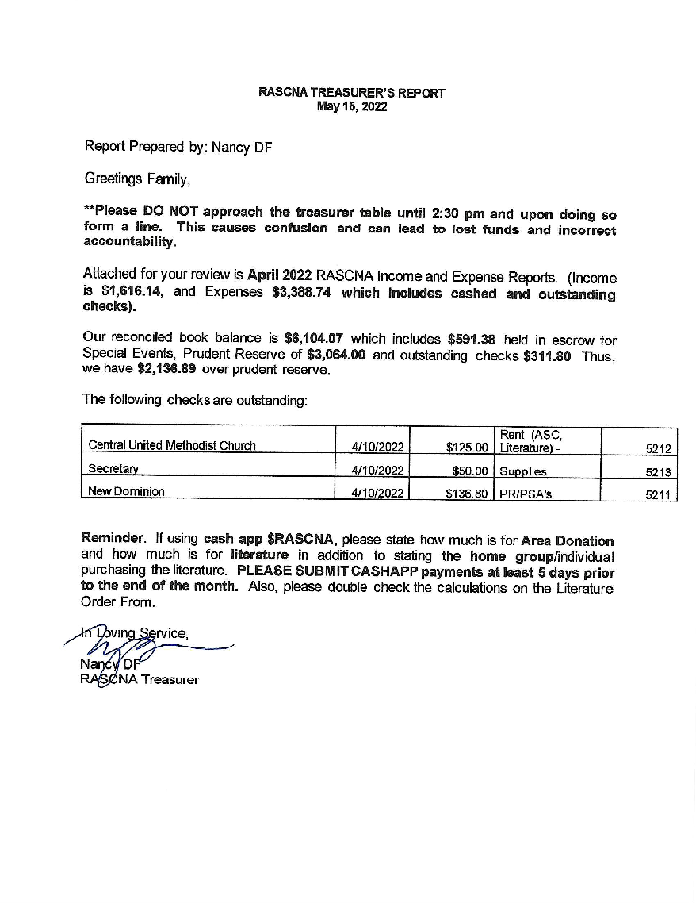
Announcements: | No treasure announcements

6. Group Reports: May 15, 2022
Atmosphere Of Recovery | Donation: $83.00 Literature Order: $0.00
Report: | The meeting is good. 15-20 members. We are in need of support.  In Loving Service, Cassandra B.
Church Hill Group | Donation: $ 0.00 Literature Order: $ 0.00
Report: | Our home group is doing well and we encourage experienced members to come out and share their experience with the newer members. We have a rotational format that allow for your support.  In Loving Service, Sulaiman F.
Easy Pace/Stepping Out | Donation: $0.00 Literature Order: $31.54
Report: | Easy Pace/Stepping Out is continuing carrying the message of hope to the still suffering addicts inside and outside of the rooms of NA  In Loving Service, Anthony F.
Freedom Group | Donation: $ 0.00 Literature Order: $ 0.00
Report: | Freedom Group continues to fulfill its primary purpose. We have an average of 15-20 people in attendance weekly.  In Loving Service, Rondell D.
Growing In Recovery | Donation: $ 0.00 Literature Order: $ 0.00
Report: | Growing In Recovery is doing well averaging 15-25 people. Groups are growing with comers William N. celebrates 23 years on May 25th at 12pm to 1:30pm  435 Circle Plaza Belt Blvd. N Hull St. Building 23224  In Loving Service, Antonio W.
Good Orderly Direction | Donation: $73.00 Literature Order: $ 0.00
Report: | GOD Continues to do well carrying the NA message via virtual platform, with steady attendance and home group member participation. Shayne J celebrates 2 years clean tonight at 7pm at Hatcher. Tawanda T. celebrates 8 years on July 8th, and Carolyn R. will celebrate 13 years clean.(celebration date, still to be determined)  In Loving Service, Hakim L.
Long Haul | Donation: $25.26 Literature Order: $46.74
Report: | Long Haul group is doing well and we are still maintaining good attendance and participation in our meeting. Katy S. will be celebrating 1 year June 20th 2022.  In Loving Service, James M (pro temp)
Monday Reality | Donation: $ 0.00 Literature Order: $ 0.00
Report: | Good Afternoon, Monday Reality is doing well. We continue to have good attendance and will be in contact w/ the church in reference to going back in person/hybrid. Our home group member previously spoke w/the church and will be following up before the end of this month.  In Loving Service, Monday Reality
More Will Be Revealed | Donation:$23.26 Literature Order: $ 0.00
Report: | All is well at More Will Be Revealed. We are still averaging 20-25/wk. we are following our primary purpose (tradition 5) where we are getting attendance from all over the country Via the Zoom Platform.  In Loving Service, Richard W.
New Beginnings | Donation:$15.46 Literature Order: $64.20
Report: | Our home group is doing well. We have a lot of newcomers.  In Loving Service, New Beginnings Home Group
New Birth | Donation: $0.00 Literature Order: $0.00
Report: | New Birth Home group is doing well and continues to receive new comers weekly. The home group has new members that joined the home group and will hopefully take a new position. The New Birth continues to carry the message according to our fifth tradition.  In Loving Service, Edwina P.
Rainbow’s End | Donation: $7.85 Literature Order: $63.34
Report: | Steven K. is celebrating 2 years on May 20th.  In Loving Service, Chance P.
Staying Clean | Donation: $ 0.00 Literature Order: $ 0.00
Report: | Staying Clean is doing well and new members are coming.  In Loving Service, Antwain C.
Stepping On Sundays | Donation: $ 0.00 Literature Order: $ 0.00
Report: | No Report  In Loving Service, Jacob T.
Sunday Spiritual | Donation: $58.72 Literature Order:$67.28
Report: | Sunday Spiritual continues to do well. With attendance averaging between 20 to 30 members.  In Loving Service, Neal E.

7. Area Trusted Servants’ Reports: December 12, 2021
RACC | 5/15/2022  Hello Family,  The Convention Committee is doing well. The next scheduled meeting will be held per virtual platform on June 6thm 6:00pm. We approved two other fundraisers for June and July. I do believe that PR has received both the flyers. Registration can be made via the rccana.org website. The next upcoming event is the Father's Day (June 28th 2-6pm) 436 Calhoun Recreational Center.  The next is a Spiritual Breakfast July 23rd, 2022, from 10:00am-1:00pm 1920 Fairmount Ave. Please come and support this event as well. Let’s not forget all proceeds go to the Convention Committee for Convention in October.  Attached you will find the treasurer's Report for the past month. There is a reconcile balance of available funds of $20,533.72.  The support for this convention is a true reflection this Area’s Consciences . The attendance has been very low and inconsistent. Since the open- Forum was put in place to address the Areas needs directly there has been no one attending expect the Convention Committee trusted Servants.  As a member of this body and NA as a whole. There has been some major concerns I have witness during this transition. We have an outdated Policy that is not cable of addressing Area’s needs as a whole. However, just because the Policy needs to be updated. There policies that re already in place and we should be more concern with addressing how in the future are we going to continue to carry the message, by utilizing the tools we do have in place.  We do not govern, we were voted in to adhere to the principles of the program and not our own self will. I believe if we follow the principles we will find the solutions we seek as a whole.  There policies we are not following which we need to address ASAP.  . In Loving Service, Ron B.
Announcements:
Policy | Good evening policy is doing well; thank you all for allowing me the opportunity to serve and I am looking forward to serving with our new Vice Chair. We are on schedule with the updated version of policy. Looking forward to a great day and thank you for allowing me to serve.  In Loving Service, Michael A.
Announcements: | Michael A., (804) 247-6752, Email: rascnapol@metrorichmond.org
Public Relations | Thank you for providing me with the opportunity to continue in this role. I want to take a moment and remind anyone who would like to be of services and participate in the PR subcommittee we meet the 1st Monday of every month virtually at 6pm. The information to log into the meeting can be found on the RVANA.org website under the Service tab at the top and in the regular meeting schedule un the Monday tab.  We also meet as a unified region meets for the unified PR meeting on the 3rd Monday of the month and that meeting information can also be found on the website.  If your meetings need to be updated for changes or closures, including inclement weather. Please send an email to rascnaprc@metrorichna.org. I, our web-servant Howard, and our social media coordinator Steven R will receive it to help ensure that they are addressed in a timely manner.  If you have any flyers for the website or social media, please use the same email address listed above.  RVANA PR assisted the regional PR with their presentation to DOC. This was a virtual meeting with roughly 32 attendees when at its highest point. The DOC enjoyed the presentation wanted to hear the personal testimonies of each of the presenters.  During our interactions we discovered that state DOC facilities for Virginia do not allow “Behind the Walls” meetings anywhere in the state. They also have removed NA and other 12-step meeting requirements for the probationers or supervisee exit plans. Dues to recently lost lawsuits claiming the 12 step meetings are faith based.  However, if the judge orders them to 12 step meetings, they do not override the judge’s orders.  PR week is coming up in June and RVANA is hoping to work with other PR subcommittees in the area to spread the word. With it being convention time of the year, we’re looking for creative ways to spread the message to the addict that still suffers.  March 2022:  The website stats for March 2022  - Up to 2,656 users compared to 2,472 for March 2021.  This is an increase of 7.45%. There were 2,145 new users to the website. Finally, the website had 18,793 visitors overall.  The phoneline  - 6 Just For Today readings  - 5 Meeting Searches  - 15 Volunteer Calls.  Web Servant Report: The website is constantly updated as many meetings move back to in-person gatherings. There is a new meeting added to the schedule on Saturdays at 11 am Principles Over Personalities. The website is also updated with flyers for the Convention and upcoming events. Please continue to send information and check to see that the website is updated within 48 hours.  In Loving Service, Lance O.
Announcements: | Lance O., (804) 248-1736, rascnaprc@metrorichmond.org.
H&I | Good Evening Fam, hope all is well H&I subcommittee is doing very well. We’re carrying the message to those addicts that still suffer at many facilities. We’re meeting in person and have moved from 1205 w. Franklin St. over to 1211 Porter St. on second Sundays from 1pm to 2pm and the fourth Sundays from 2pm to 3pm. As of 4/24/22 our H&I Literature coordinator has step down from his position. We have a new member.  In Loving Service, Tonya D.
Announcements:
Outreach | Absent  In Loving Service, Mason R.
Announcements: | NONE
Special Events | Absent  In Loving Service, Latasha D.
Announcements: | NONE
Special Events Treasurer | No Report  In Loving Service, Sheila G.
Announcements: | NONE
Hello Family,
The 214th RSC was held 4/17/2022 on zoom. There were 10 RCM’s during open forum 9 RCM’s at the start of the 214th RSC. During open forum Randy (RD) will be distributing Basic Text’s provided by the ECCNA to Each H&I within the region. I will pass on further updates as I receive them. Starting balance as of 2/19/22 is $16,912.65, Income $1,615.18, Expenses $677.58. Current balance as of 4/17/22 is $17,850.25. “As this puts us about $260.00 below prudent reserve we will not be making a donation to NAWS at this time.” According to the VRCC report the 39th AVCNA was well attended with approximately 500 attendees. Unfortunately our budget for this convention was much more than what we brought in. Our total spent was 58,550 and total revenue was $47,241 at this time we are still under prudent reserve. Elections and nominations- 1- Vice Treas. 2- Treas. 3- Speaker Jam 4-Vice Chair 5- H$I Chair 6-Policy Chair. There are no motions to take back to groups at this time. Next RSC is June 18th 10am
In Loving Service Val R.
Addendum to Regional Report :
Events: Back to Basics Workshop
Enjoy the Journey Home Group Saturday May 21st 11:00am- 2:00pm
Waters Edge Church 4141 Holland Rd. VA Beach
$10.00 Spiritual Breakfast and speaker RACNA 3
$15.00 at door June 4th 10:00am-noon
Trinity Episcopal Church 825 College Ave.
Fredericksburg, VA 22401
FREE 31st Annual Unity Day Picnic
Sunday June 5, 2022 11am-4pm Bayville Farms Park shelter #3 VA Beach (no pets)
Food, fun, fellowship, volley ball, and basketball.

VRCC / Alternate VRCC | VRCC met this weekend for the 40th AVCNA retreat in VA beach I want to bring to the attention of our RACNA convention committee the awesome experience I had at the retreat with the BINGO fundraiser I really enjoyed bingo and would like our area to consider having Bingo as a fundraiser event in the near future It also raised $600 after only 1 hour and 15-20 participants . So I’m sure it’s a money maker. Our very own Kelli M has been elected as vice treasurer the treasurer of VRCC treasurer is in the process of finding an accountant to complete our financial report and file our taxes which are due In July 2022. AVCNA 40 has a Facebook account AVCNA 40 we are looking for AVCNA 41 bids due by July The next VRCC meeting will be held on July 24th location will be forwarded later.  In Loving Service, Julie T.
Announcements:
Literature | Hello Family,  I’m Grateful to be at area today, after having surgery. The literature arrived was stamped and inventoried. We would like to thank the area for the extra money so that we could stack the literature room back up so that we could serve our area better. We have completed all back orders. Please check your orders before you leave the literature room. All GSR’s must use the March 2021 order form.  In Loving Service, Bobby L.
Announcements: | NONE
Print Shop | Hello Family:  A continued thank you for the opportunity to serve. Each month grows smoother with the print shop. Today things were ready by 2:15 pm.  A reminder to please complete the sign-in sheet and indicate if you would like minutes mailed to you.  In Loving Service Howvard B.
Announcements: | NONE

- Old Business:
Procedural Motion(s):
- Motion: To utilize the Cash App as a means of payment for the zoom account.
Intent: To allow area the means to carry out responsibilities to the area also to allow groups that do not wish to meet in person to continue to utilize the platform
Motion Maker: Richard W. seconded by: Sulaiman F.
RASCNA Vote: Tabled

Pros | Cons

- Nominations and Elections

ELECTED
Names | Position
Kim M. | Vice Chair
Sheila G. | Special Event Treasurer
NOMINATIONS
Names | Position
None
VACANT
No further nominations received | Assistant Treasurer
No nominations received | Assistant Secretary
No nominations received | Alternate RCM
No nominations received | Alternate VRCC Director

- New Business:
Procedural Motion(s):
- Motion: To add a line to Section H page 41 stating that the prudent reserve exists and is equal to one mone primary and secondary total expenses.
Intent: To define and reflect Prudent Reserve in policy.
Motion Maker: Policy Subcommittee / seconded by NOT REQUIRED.
RASCNA Vote: 13/0/0 Passed

- Motion: To revise the prudent reserve to include one month primary and secondary expenses. When primary and secondary expenses increase or decrease the prudent reserve will be adjusted accordingly.
Intent: To correct the current prudent reserve reflected in policy and the current treasurer report
Motion Maker: Policy Subcommittee / seconded by NOT REQUIRED.
RASCNA Vote: 12/0/1 Passed

Guideline Motion(s) [to the groups]:
- Motion: To Include those Zoom meeting that are still carrying the message via the virtual platform. The hard copy meeting list should be inclusive of those meetings.
Intent: That all members can access in-person and virtual meetings. Tradition:5 Concept:5,7,11
Motion Maker: Richard W. Seconded By: Sulaiman F.
Voting results to take back to groups: Resended

- Motion: To have the Richmond area have a zoom account
Intent: To allow the area to carry the message more effectively
Motion Maker: Simone W. Seconded By: Richard W.
Voting results to take back to groups: Resended

Regional Motion(s) [to the groups]:
None

Pros | Cons

- Money Matters:
  - Motion: To increase the gas reimbursement from $35.00 to $55.00
Intent: Because of increase in gas prices.
Motion Maker: Julie T. VRCC Chair / seconded by Tonya D. H&I Chair
RASCNA Vote: 10/0/1

- Next ASC Meeting: June 12, 2022 / 3:00pm / 1211 Porter Street, Richmond, VA 23224
Date Time Place

- Other Pertinent Announcements:

Motion to Close with the Serenity Prayer: Kim M. / seconded by Sulaiman F. at 5:49pm

