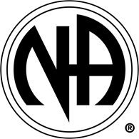
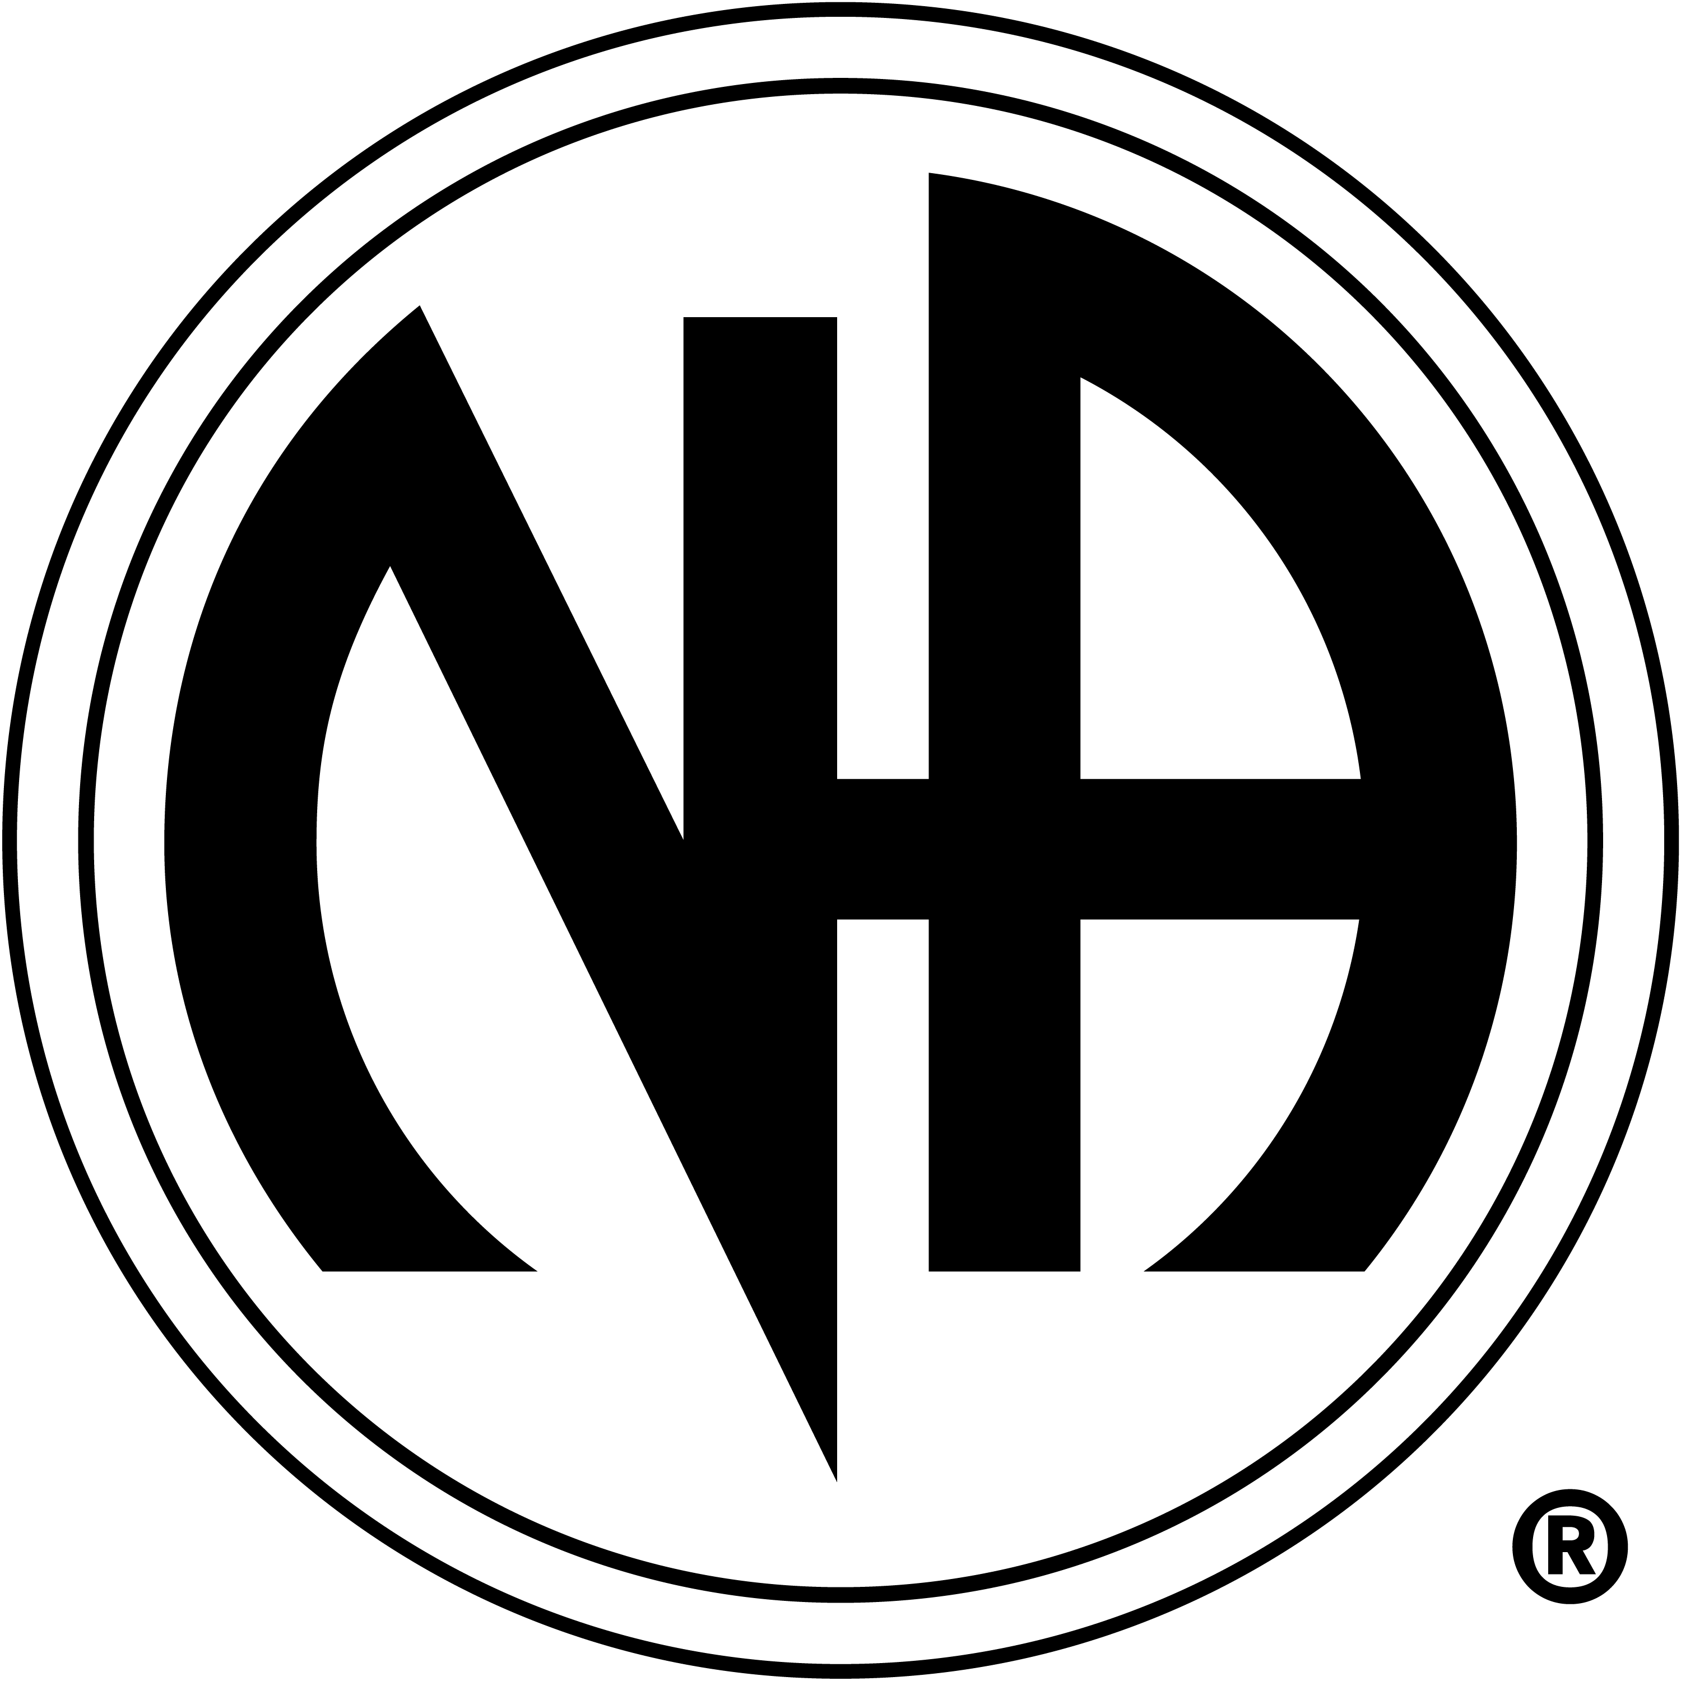
The Richmond Area
Literature Subcommittee
Presents
Literature Room Reopens
Volunteers are welcomed!!

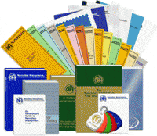

When: Every 4th Saturday
- October 24, 2020
- November 28, 2020
- December 26, 2020
Time: 8:30am-10:00am

Where: Atlee-Northminister Church
3121 Moss Side Avenue, Richmond, VA 23222
Curb Service
- Download the literature form from our website, rvana.org
- Bring a money order with you or Cash App to $RASCNA
- A blank literature form will be placed in your bag
- Wear a mask

