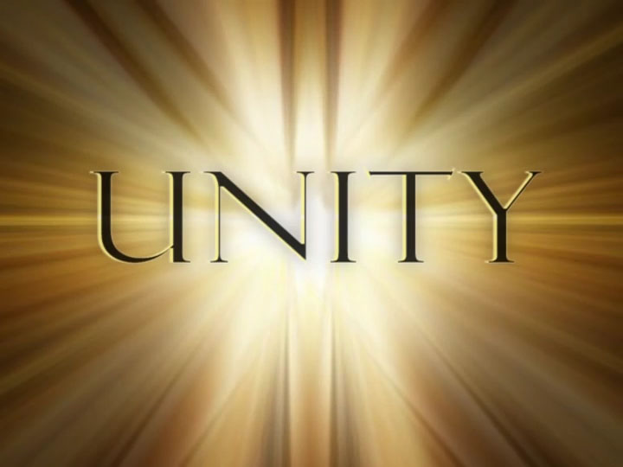  OCT 13, 2018  Richmond and New Dominion Areas Special Events have joined together for a Unity Day Event.  Age, Race, Sexual identity, creed, religion, and lack of religion are all welcome!  Wear your running shoes and bring a towel and a chair.  Tickets $10.00 per person, includes lunch  50/50 Raffle  Pre Convention Subcommittee will host Bingo  With cash prizes and raffle, from 2pm-4pm  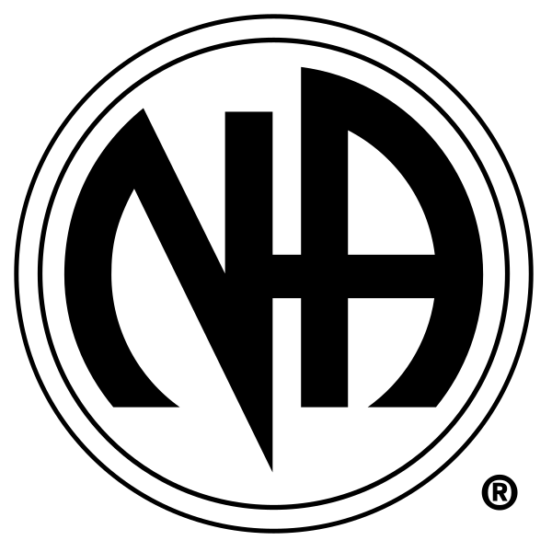 | Food and Drinks  ────  Fun and Games  ────  Fellowship  ────  2 Speakers  ────  Music  narcotics anonymous  Hatcher Church  2300 Dumbarton Rd  Amie S. (804)814-2876  Simone W (804)277-1209  For Details  10AM – 6PM

