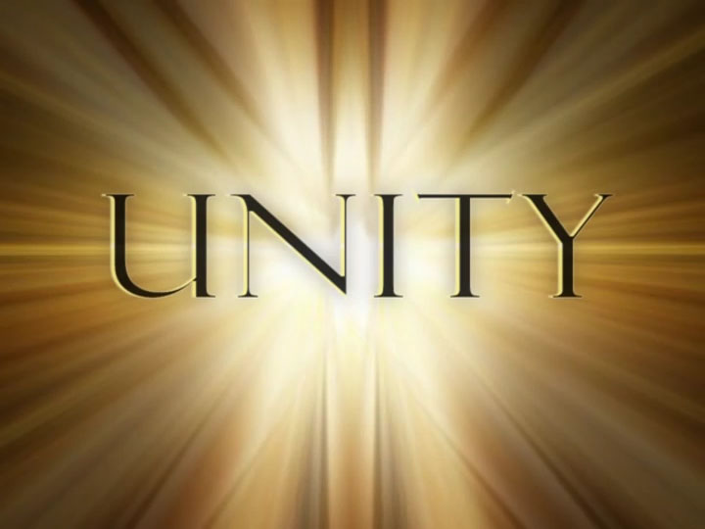  Sept 15, 2018  Richmond and New Dominion Areas Special Events have joined together for a Unity Day Event.  Age, Race, Sexual identity, greed, religion, and lack of religion are all welcome!  Wear your running shoes and bring a towel and a chair.  Tickets $10.00 per person  50/50 Raffle  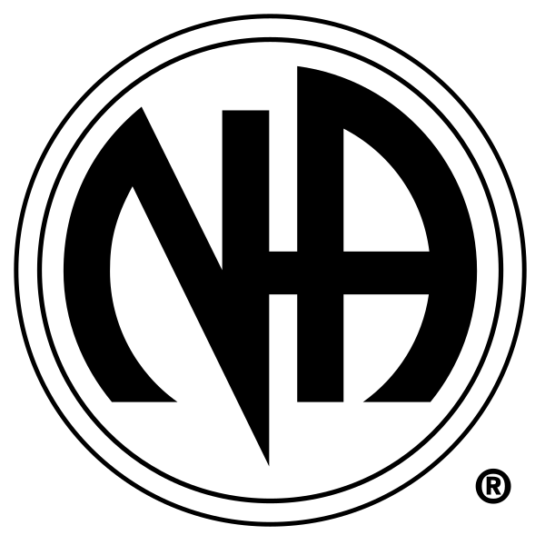 | Food and Drinks  ────  Fun and Games  ────  Fellowship  ────  2 Speakers  ────  Music  narcotics anonymous  Deep Run Park Shelter 1  Amie S. (804)814-2876  Simone W (804)277-1209  For Details  10AM – 6PM

