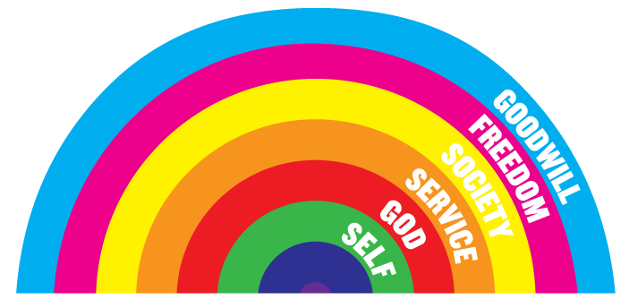

Join the **RAINBOW’S END Home Group** for our

**18th Anniversary Celebration!**

**When? Friday, October 20, 2017**

7:00 – 8:30 p.m. Dinner

9:00 – 10:30 p.m. Recovery Meeting

**Where?** **Metropolitan Community Church**

2501 Park Avenue (cross street Davis)

Richmond, VA 23220

**Theme?** **Love is the Key to Recovery!!!**