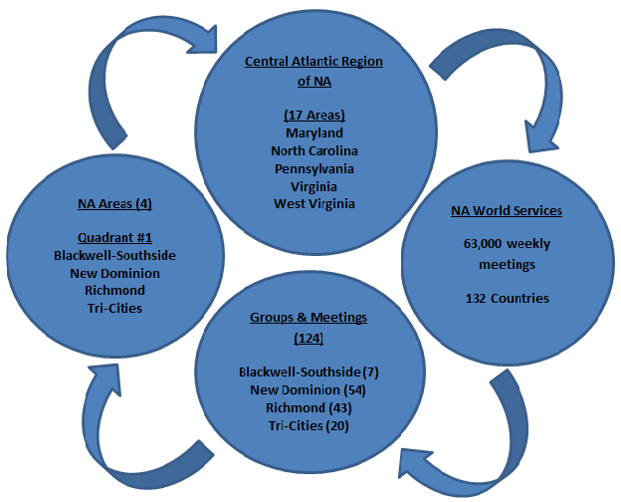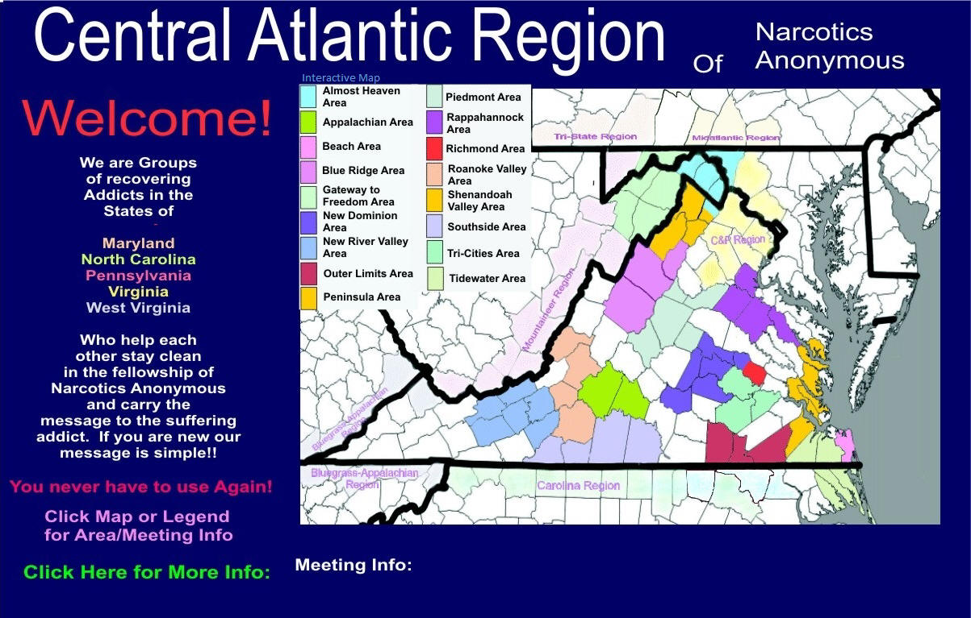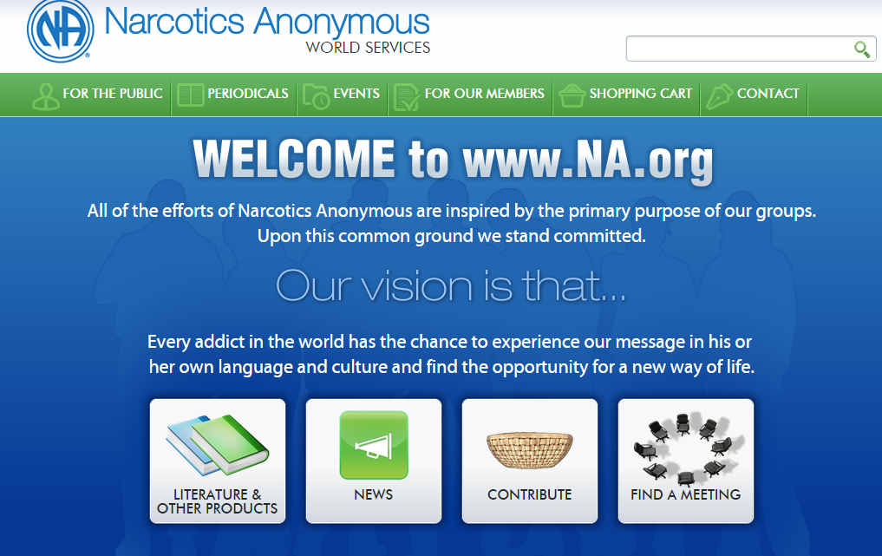

**Telephone**

**(na heLPLINE)**

**+1.804.965.1871**

Send your questions [**www.rvana.org**](http://www.rvana.org)

**and**

Click on “Contact Us!”

# Blackwell-Southside, New Dominion, Richmond, and Tri-Cities Areas

NA groups—not NA meetings—are the foundation of the *NA Service Structure.* By joining a home group, you pledge your support to help make *service decisions* that directly affect your group, other groups, and ultimately Narcotics Anonymous as a whole.

For example, any proposed changes to NA’s Twelve Steps, Twelve Traditions, name, nature, or purpose must be approved by the groups before they can take effect.

The way that groups stay in contact with the rest of NA is through their GSR or Group Service Representative.

This person attends Area Service to help coordinate efforts to carry the message of recovery in your area. At least once a year, the GSR attends the regional assembly. This chain of representation continues from Region all the way to World Service.

So in addition to providing a place to recover, your NA group takes part in the continued evolution of the Fellowship of Narcotics Anonymous.

### **Below: The current NA Service Structure for the Richmond-Metro Areas.**

## Why participate in your NA home group?

The Unified News of NA

*The purpose of this periodical is to research and respond to questions and concerns presented to the Unified PR Subcommittee that may impact our personal recovery and the fellowship.*

Inside this issue:

Groups 1

Areas 2

CARNA 3

NAWS 4

Volume 1, Issue 1

March 1, 2015

Volunteer subcommittees coordinate services within our community. Because NA accepts no financial contributions from non-members, has no professional counselors and maintains no clinics or residential facilities, we count on our members to deliver the list of services below:

* **Community Awareness Meetings** inform the community of the existence of Narcotics Anonymous and its available services.
* **Health Fairs and Conferences** are events conducted by professional organizations at which NA has presents information.
* **Presentations** are often provided to churches, parole officers, judges, counselors, nurses, doctors, and schools, among others..
* **Public Service Announcements** are created to provide information about NA distributed to the public via the media.
* **Phoneline Services** include a helpline number which has NA members who volunteer to talk to others addicts and provide information.
* **Meeting Lists** are locally produced schedules available in print, on-line at [**www.rvana.org**](http://www.rvana.org) and searchable by smart phones.
* **Services to Hospitals & Institutions (H&I)** provide meetings or presentations to hospitals, jails, addiction treatment facilities, detox centers, and other institutions.
* **Literature Services** include a variety of books, booklets, pamphlets, audio and large-print editions (available in several languages).

**Check out the Calendar of Events on the unified website,** [**www.rvana.org**](http://www.rvana.org) **for times, dates and locations of Area’s subcommittees.**

### Join a Subcommittee, Serve Your Community!

**Blackwell-Southside Area**

**2408 NEW HARVEST RD**

**HENRICO, VA 23231**

**New Dominion Area**

**PO Box 25025**

**Richmond, Virginia 23260**

**richmond Area**

**PO Box 26249**

**Richmond, Virginia 23260**

**TRI-Cities Area**

**PO Box 947**

**Colonial Heights, Virginia 23834**

**Telephone**

**(na heLPLINE)**

**+1.804.965.1871**

Email Addresses

We’re on the Web!

*See us at:*

**www.rvana.org**

Concept One for NA Service states, “To fulfill our fellowship’s primary purpose, the NA groups have joined together to create a structure which develops, coordinates, and maintains services on behalf of NA as a whole.”

This structure is called an “Area” committee. In Richmond Metro, we have four Area committees – Blackwell-Southside, New Dominion, Richmond and Tri-Cities – consisting of some 124 groups and meetings within minutes of each other.

These Area committees exist to help groups share their experience with one another, provide tools which help groups function better, attract new members to group recovery meetings, and carry the NA message further than any single group could carry it along.

Area committees cannot provide much needed services to their groups unless groups provide the direction, conscience, ideas, people, and money needed to carry them out.

**If your group needs help with meeting your Area responsibilities, contact the Area’s Outreach Subcommittee.**

## The Purpose of Your Area Committee

page 2

The Unified News of NA

**CARNA**

**PO Box 1959**

**Chesterfield,**

**Virginia 23832**

**Telephone +1.800.777.1515**

E-mail addresses

We’re on the Web!

*See us at:*

**www.car-na.org**

## What Is CARNA?

**Central Atlantic Region of Narcotics Anonymous (CARNA)** is a group of recovering addicts in the states of Maryland, North Carolina, Virginia, Pennsylvania and West Virginia.

Just like those of us who serve in our home groups and area committees, delegates to CARNA help each other stay clean by ensuring that our fellowship will continue to carry the message to the still sick and suffering addict.

There are 17 areas which make up this region. The groups within these areas have joined together to create a structure which develops, coordinates, and maintains services on behalf of NA as a whole.

Services include outreach, public relations, meeting locations, helpline, and speaker’s jams.

**If you are traveling and wish to visit meetings within this region, access the website at**

**www.car-na.org**

**or call the helpline at**

**1-800-777-1515**

The Unified News of NA

page 3

## We Are a World-Wide Organization!

The vision **Narcotics Anonymous World Service (NAWS)** is:

“Every addict in the world has the chance to experience   
our message in his or her own language and culture”  
and find the opportunity for a new way of life.

Narcotics Anonymous sprang from the Alcoholics Anonymous Program of the late 1940s, with meetings first emerging in the Los Angeles area of California, USA, in the early Fifties. The NA program started as a small US movement that has grown into one of the world's oldest and largest organizations of its type. Narcotics Anonymous is a global, community-based organization with a multi-lingual and multicultural membership.

Today, Narcotics Anonymous is well established throughout much of the Americas, Western Europe, Australia, and New Zealand. Newly formed groups and NA communities are now scattered throughout the Indian subcontinent, Africa, East Asia, the Middle East, and Eastern Europe. The numbers speak for themselves:

**NA literature in 41 languages**

**63,000+ weekly NA meetings**

**In 132 countries**

Through all of our service efforts and our cooperation with others seeking to help addicts, we strive to reach a day when every addict in the world has an opportunity to experience our message of recovery in his or her own language and cultures.

**To learn more about NA World Service, visit** **www.na.org****.**

**NA World Services**

**PO Box 9999**

**Van Nuys, California USA 91409**

**Telephone +1.818.773.9999**

**Fax +1.818.700.0700+**

Email addresses

We’re on the Web!

*See us at:*

**www.na.org**

**The Unified News of NA**

page 4